**User Registration for All Roles**

**Brent Kosior**

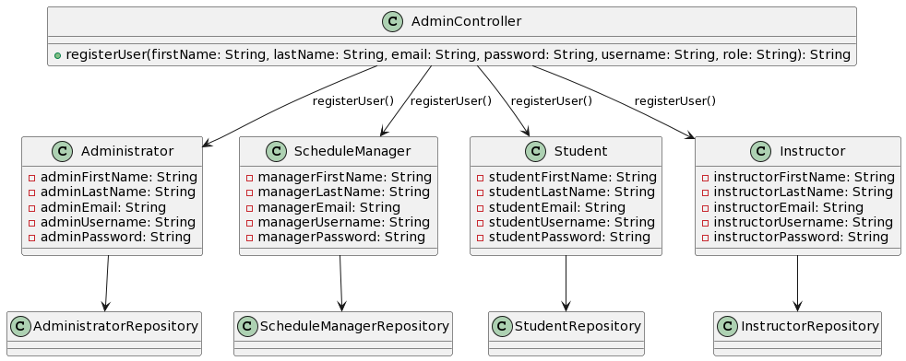

@startuml

class AdminController{

+ registerUser(firstName: String, lastName: String, email: String, password: String, username: String, role: String): String

}

class Administrator {

- adminFirstName: String

- adminLastName: String

- adminEmail: String

- adminUsername: String

- adminPassword: String

}

class ScheduleManager {

- managerFirstName: String

- managerLastName: String

- managerEmail: String

- managerUsername: String

- managerPassword: String

}

class Student {

- studentFirstName: String

- studentLastName: String

- studentEmail: String

- studentUsername: String

- studentPassword: String

}

class Instructor {

- instructorFirstName: String

- instructorLastName: String

- instructorEmail: String

- instructorUsername: String

- instructorPassword: String

}

AdminController--> Administrator: registerUser()

AdminController--> ScheduleManager: registerUser()

AdminController--> Student: registerUser()

AdminController--> Instructor: registerUser()

Administrator--> AdministratorRepository

ScheduleManager --> ScheduleManagerRepository

Student --> StudentRepository

Instructor--> InstructorRepository

@enduml